~Asia-China-Mirror-Han-Four bat and mice with continuous arc
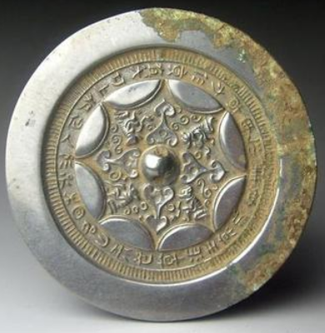
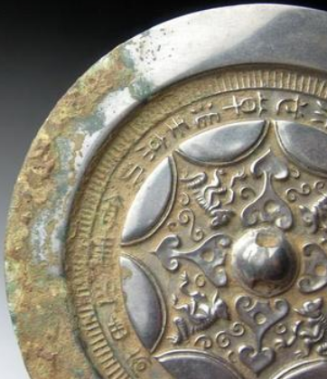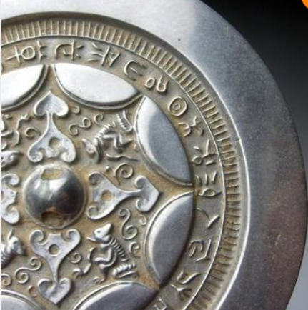

Han Dynasty semicircle grass auspicious inscriptions bronze mirror 5in

